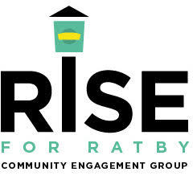

Notice of Public Meeting

Location: St Philip & St James Church Ratby.

Date: Wednesday 30th October 2024. Time: 7.30 pm

The meeting has been called in response to Lagan Homes officially submitting their outline planning application to build 470houses, or 450 houses, a school, care home and community hub on the land west of Ratby locally known as the Burroughs, this has been done before the HBBC local plan consultation has been concluded!

The village has a very short window of time in which to come together and unite to fight this now very real threat to our village and community.

We need to believe in the collective power of the many, and above all, try! We owe it to future generations!

We will lose this view forever if we do not!

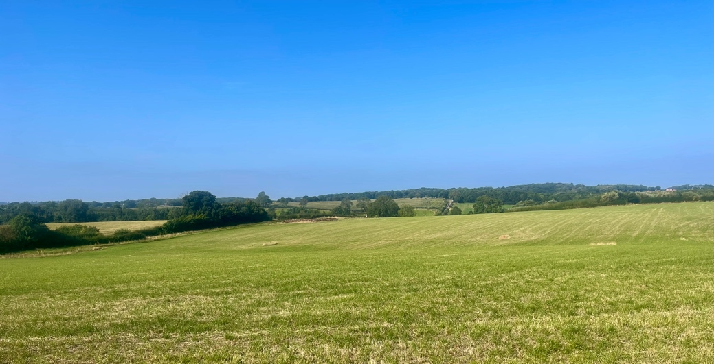

Come along and get involved, join our growing volunteer group.


For those who are unable to attend the meeting will be streamed through Facebook live
On our private ‘Rise for Ratby’ group. Details will be provided on the group nearer the time.

‘Save our Burroughs’, say NO! to Lagan Homes
‘Save our Burroughs Campaign’

Rise for Ratby - Community Volunteer Group

In response to Lagan Homes submitting their outline planning application our group of resident volunteers will begin personally distributing letter templates and objection guides to every household in the village, they will also aim to provide you with help and guidance on how to object and how to complete your letters.

Please let us know if you need help writing your letters, or if you need someone to write it for you should you have difficulty in writing them. See website and Facebook details below for news on these services.

We appreciate everyone has different views but when our volunteers call, please be courteous and give them your respect, they simply care about the place they live.

Our village volunteers will also arrange with you a suitable date and time to collect your households completed objection letters, in the hope this will make the process as easy as possible for you.

Important note: this is not just one letter per household we really do need a letter from every single resident (no matter what age) to make it possible. If your children would like to draw or paint a picture to accompany the letter, even better!

Sign up to ensure you keep updated with village news and group activities.
www.riseforratby.org.uk

We also have a Facebook group called ‘Rise for Ratby’ either follow the link on the website or search for the group in the Facebook app.

